Age results

# Phylogenetic approach

The age data for this approach are based on:

Faurby, S.; Svenning, J.-C. A species-level phylogeny of all extant and late Quaternary extinct mammals using a novel heuristic-hierarchical Bayesian approach. *Mol. Phylogenet. Evol.* **2015**, *84*, 14–26 DOI: 10.1016/j.ympev.2014.11.001.

This source provides 1000 equally likely trees. The species ages were extracted as branch length to the parent node of each species for all trees. The estimate used for species ages were the median ages found by this method. Because of species name mismatches the following analysis includes 4019 species out of 4443 possible.

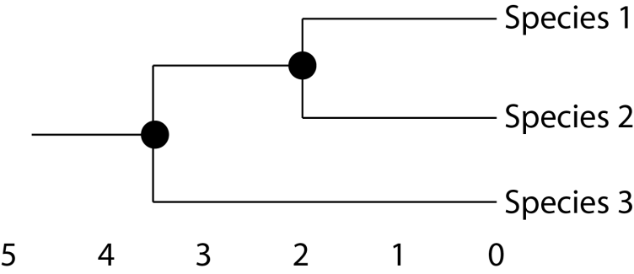

Illustration: A close-up of the edge of a phylogeny. Species 1 and 2 are estimated to be 2 Ma, while species 3 is estimated to be 3.5 Ma.

The main sources of errors are: 1) Branch lengths are not species ages, but estimated age to nearest known node where it diverged from its sister species; 2) the estimate is heavily influenced by how well known sister species; 3) the estimates are also heavily influenced by how resolved the phylogeny around each species.

To avoid obscuring the following figure with a few very large species age estimates ages were cut for graphical purposes to 20 Ma, all calculation were done with full age range.

ANOVA were run for either a 4 level factor (Cont: 1,2,3,4) or a 2 level factor (Cont: 1, 2+). Both results showed that species occurring on more continents were significantly older than species occurring on only 1. On average around 1 Ma older.

> anova <- aov(phyl.age ~ n.cont, df)

> summary(anova)

Df Sum Sq Mean Sq F value Pr(>F)

n.cont 3 264 88.14 4.084 0.00662 **

Residuals 4015 86652 21.58

---

Signif. codes: 0 ‘***’ 0.001 ‘**’ 0.01 ‘*’ 0.05 ‘.’ 0.1 ‘ ’ 1

424 observations deleted due to missingness

> TukeyHSD(anova)

Tukey multiple comparisons of means

95% family-wise confidence level

Fit: aov(formula = phyl.age ~ n.cont, data = df)

$n.cont

diff lwr upr p adj

2-1 0.95124443 0.2221578 1.680331 0.0044782

3-1 -1.85151605 -7.1947557 3.491724 0.8097677

4-1 -1.76338340 -13.7048206 10.178054 0.9813889

3-2 -2.80276048 -8.1884094 2.582888 0.5389795

4-2 -2.71462783 -14.6751014 9.245846 0.9371318

4-3 0.08813265 -12.9913004 13.167566 0.9999981

>

> anova <- aov(phyl.age ~ cont, df)

> summary(anova)

Df Sum Sq Mean Sq F value Pr(>F)

cont 1 219 218.73 10.13 0.00147 **

Residuals 4017 86698 21.58

---

Signif. codes: 0 ‘***’ 0.001 ‘**’ 0.01 ‘*’ 0.05 ‘.’ 0.1 ‘ ’ 1

424 observations deleted due to missingness

> TukeyHSD(anova)

Tukey multiple comparisons of means

95% family-wise confidence level

Fit: aov(formula = phyl.age ~ cont, data = df)

$cont

diff lwr upr p adj

2+-1 0.8945379 0.3436345 1.445441 0.0014663

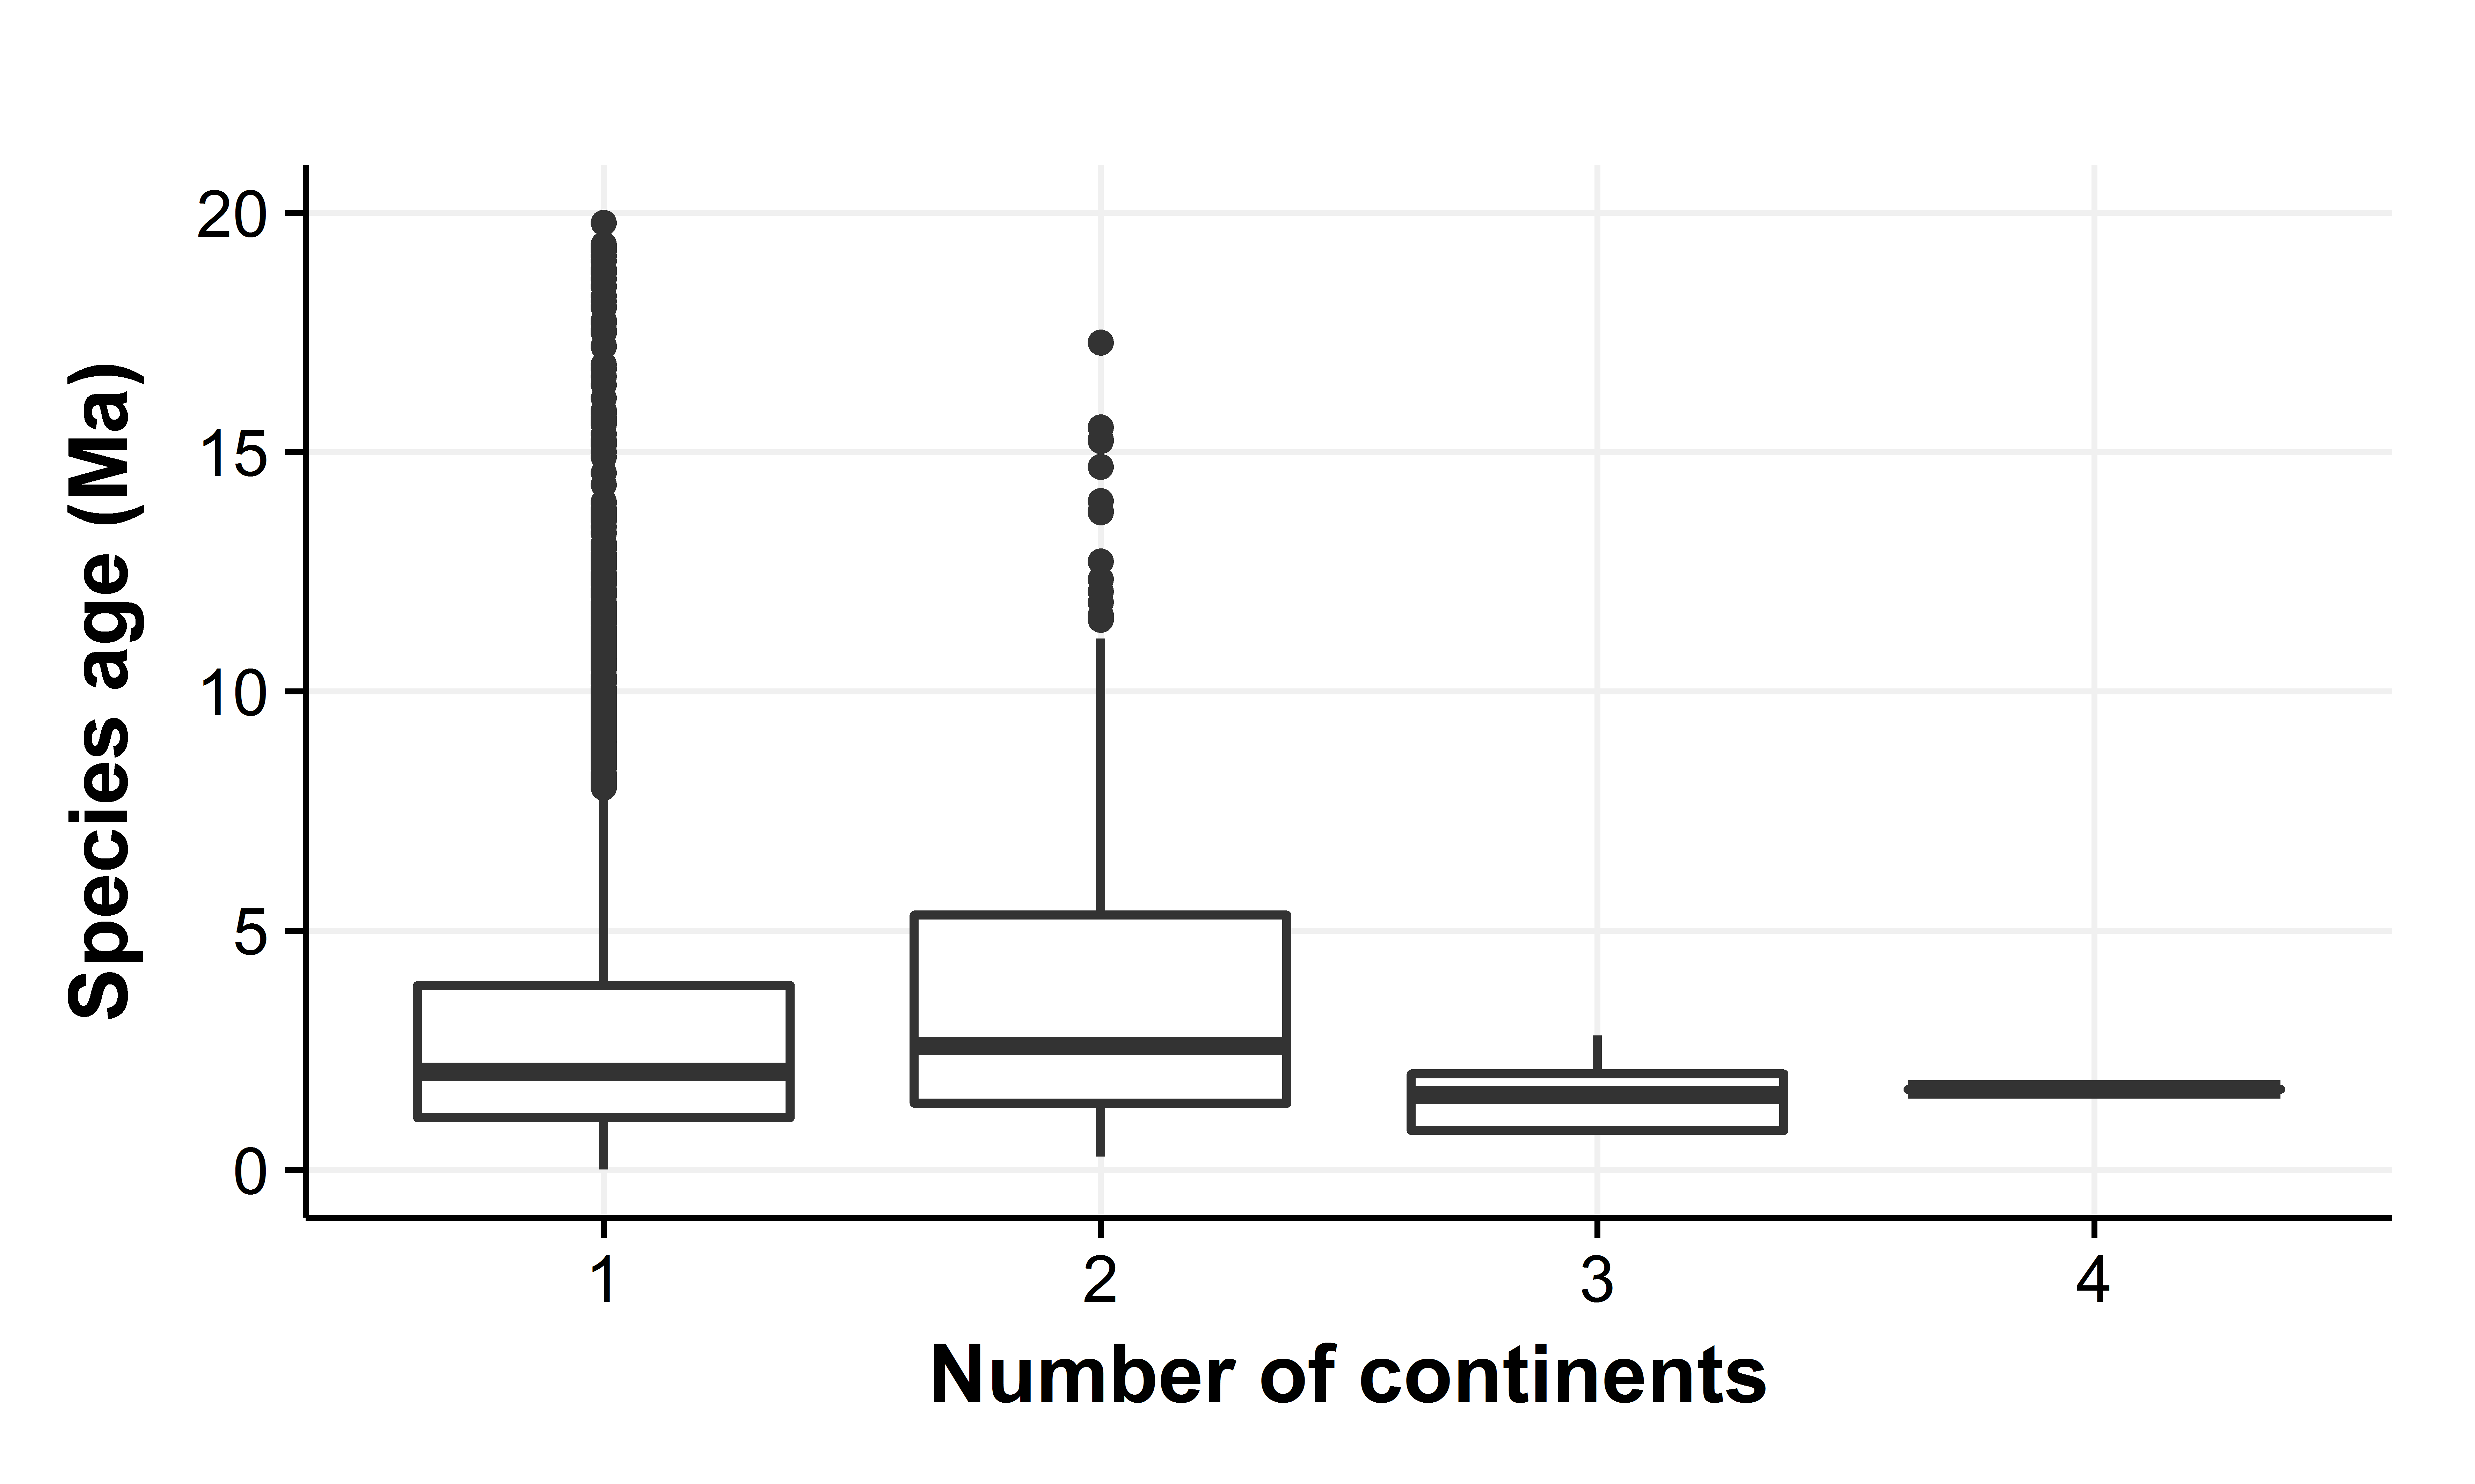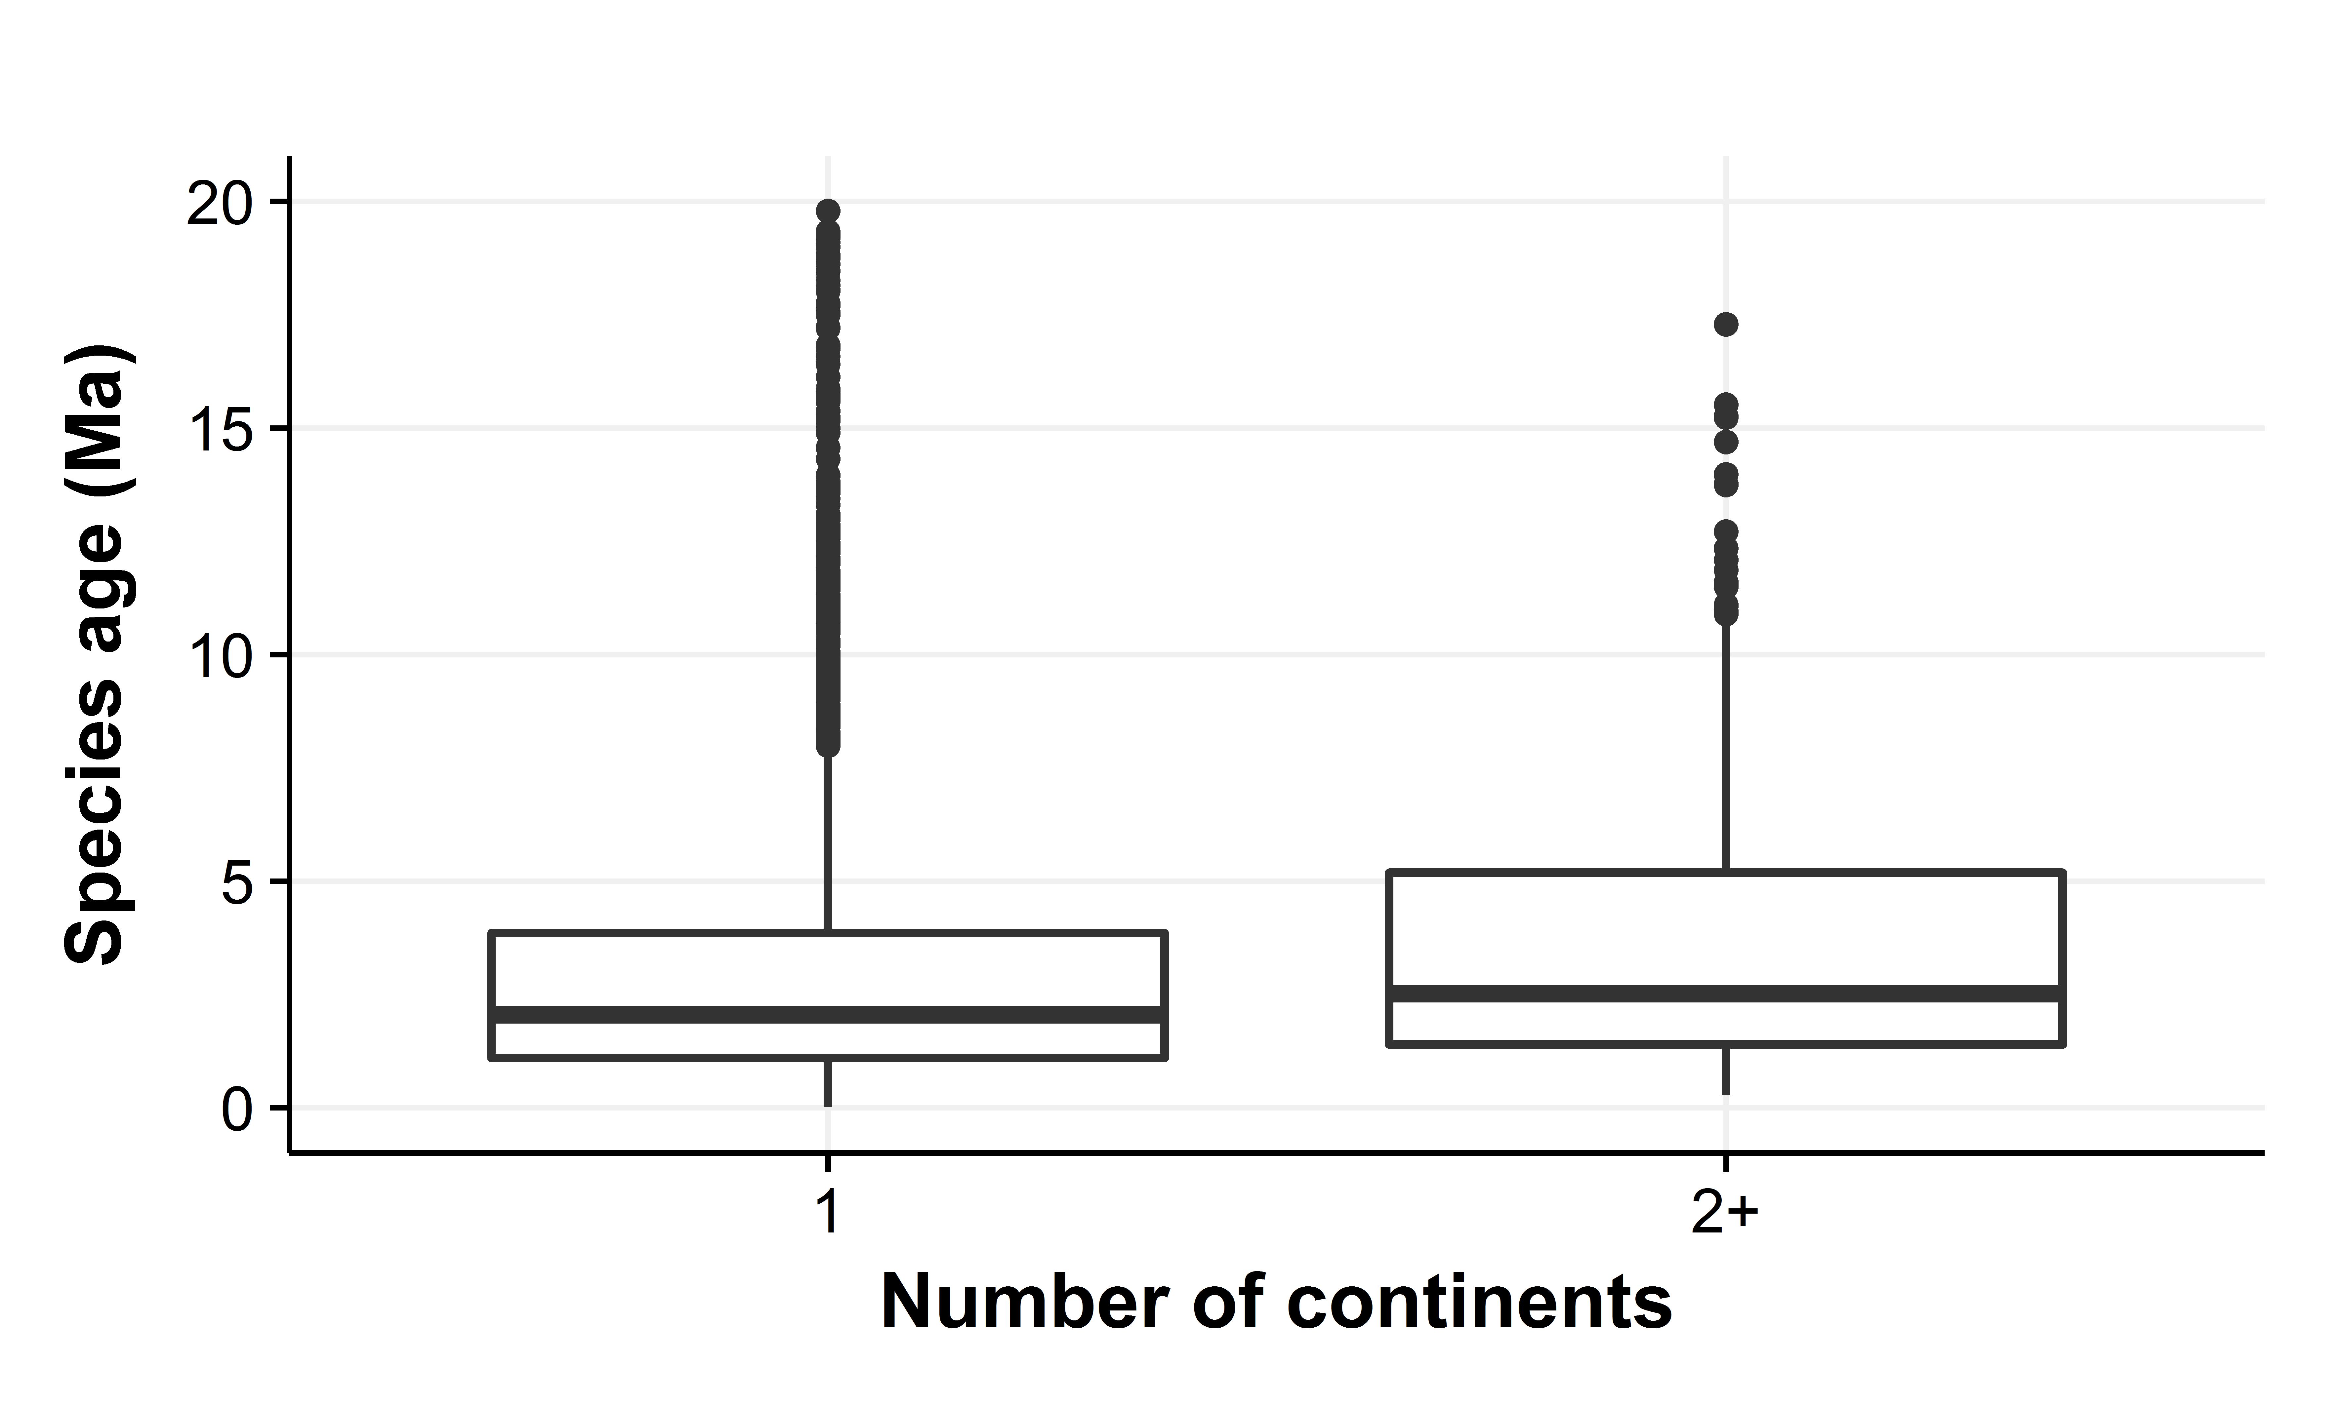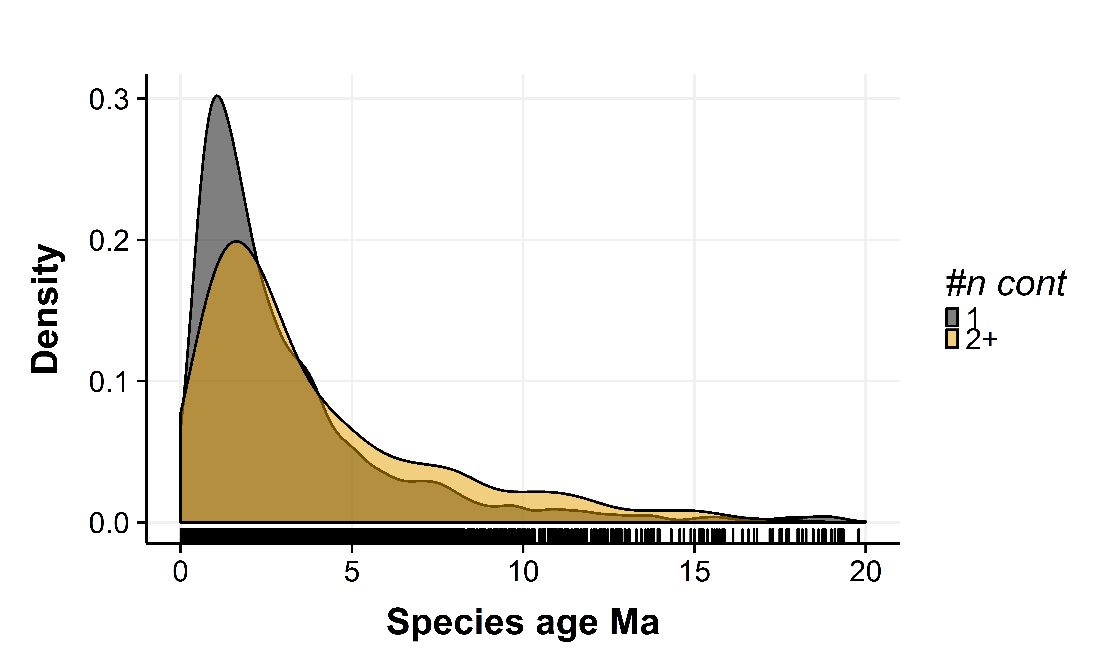

# Fossil approach

The age data for this approach are based on PBDB.

PBDB provides different fossil data at different resolutions. The ages extracted here are based only on species level identifications of fossils. All fossils are provided with a maximum and minimum estimated age. To get the most likely age of species origin we found the oldest minimum species age, and the oldest maximum species age for each species. The midpoint of this range was used as species age. Because of species name mismatches and missing species the following analysis includes 693 species out of 4443 possible.

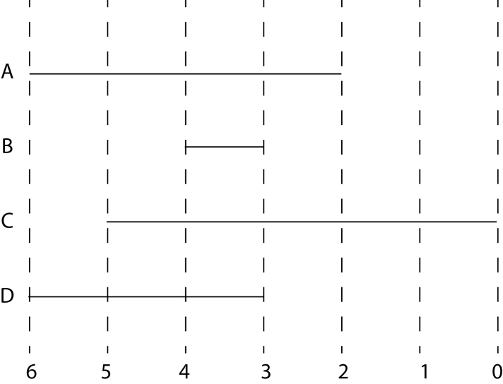

Illustration: A species was found as fossils A-D at varying ages and accuracies. Oldest min age was found to be 3 (B,D) and oldest maximum age was found to be 6 (A,D). Estimated species age 4.5 Ma.

The main sources of errors are: 1) Fossil ages are not species ages, but age of oldest found fossil; 2) the results are biased since some species are better represented and easier identified in the fossil record than others; 3) older fossils are more likely to be identified for larger species.

The fossil record did not show any difference in species ages for species occupying respectively one or more continents.

> anova <- aov(foss.age ~ n.cont, df)

> summary(anova)

Df Sum Sq Mean Sq F value Pr(>F)

n.cont 3 2.7 0.8961 0.308 0.819

Residuals 689 2002.4 2.9063

3750 observations deleted due to missingness

> TukeyHSD(anova)

Tukey multiple comparisons of means

95% family-wise confidence level

Fit: aov(formula = foss.age ~ n.cont, data = df)

$n.cont

diff lwr upr p adj

2-1 0.1200490 -0.3588595 0.5989574 0.9170942

3-1 -0.1727169 -2.3753111 2.0298774 0.9970839

4-1 1.1717831 -3.2222671 5.5658334 0.9021502

3-2 -0.2927658 -2.5322827 1.9467510 0.9868504

4-2 1.0517342 -3.3609398 5.4644082 0.9276887

4-3 1.3445000 -3.5640395 6.2530395 0.8949576

>

> anova <- aov(foss.age ~ cont, df)

> summary(anova)

Df Sum Sq Mean Sq F value Pr(>F)

cont 1 1.2 1.24 0.427 0.513

Residuals 691 2003.9 2.90

3750 observations deleted due to missingness

> TukeyHSD(anova)

Tukey multiple comparisons of means

95% family-wise confidence level

Fit: aov(formula = foss.age ~ cont, data = df)

$cont

diff lwr upr p adj

2+-1 0.1188904 -0.2381576 0.4759384 0.5134729

